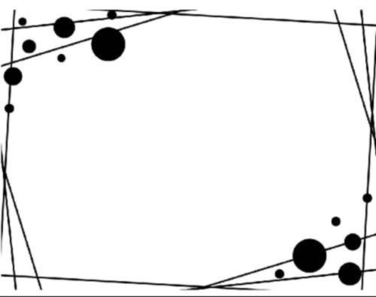

***Confirmation Letter for ASR Fellow***

* ASR kindly invites you to join in and work on the scientific and technical committees of the conferences and journals editorial boards. Membership in the ASR scientific and technical committees can open windows of opportunity for your professional growth and development as free-of-charge. Through special scientific and technical committees and divisions, and numerous occasions for scientific and technical exchange with colleagues, ASR gives scientists the power to enhance their knowledge, skills, and professional options.
* Please confirm the following information, if something needs correct, please tell us directly.



***Personal Information***

|  |  |
| --- | --- |
| **Name** |  |
| **Organization/ Institution** |  |
| **Title/Position** |  |
| **Nationality** |  |
| **E-mail** |  |
| **Research Fields** |  |